Up: Dr. Michael Stiber's Home Page

Lesson 1: Signals in the Physical World, Part A

Introduction
This lesson introduces the fundamental concepts of multimedia from an ``outside the computer'' perspective. I define the term ``multimedia,'' discuss why it is an important issue, how multimedia signals (sound, images) are generated in the ``real world'' (by both natural and artificial means) and how we perceive them. When you are done with this lesson, I hope you will appreciate the complexity and importance of multimedia communications and will be eager to see how signals can be processed by computer.

Multimedia and Sensation
``What can give us surer knowledge than our senses? With what else can we better distinguish the true from the false?'' Lucretius
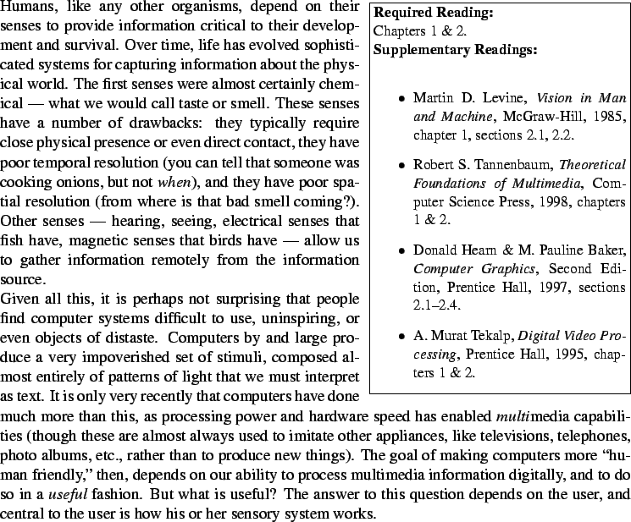

Sensation and Perception
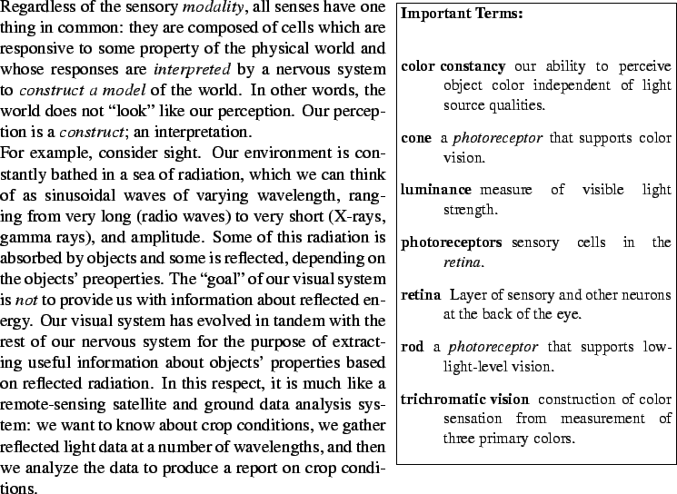
Likewise, when we ``see'' a chair, what we perceive is no more a chair than the word ``chair'' is a chair. It is an internal representation of a chair -- a useful representation, which can allow us to recognize the object's purpose, location, size, composition, etc., but a representation nonetheless. What we perceive about the world is at least as much a psychological issue as a data acquisition one. For brevity's sake, however, I will confine myself in this section to discuss the basics of ``low-level'' sensory organs, rather than high-level perceptual issues.
Our eyes are made up of an optical system and a sensory system. The sensory system -- the retina -- is composed of a number of different kind of nerve cells arranged in well-structured layers. I won't go into the details of the eye's structure, but instead concentrate on one class of cells: the photoreceptors.
Photoreceptors are specialized cells that contain pigments that absorb light and respond electrically (to make a complex matter simple). Each pigment is responsive to a fairly narrow range of light wavelengths, and in total, we can see a range of visible light with wavelengths between roughly 400 nanometers ( 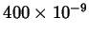meters) to 700nm -- this from an electromagnetic spectrum that covers 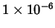nm to thousands of kilometers.
Our eyes have photoreceptors specialized for color vision at high (daytime) light levels (called cones) and photoreceptors specialized for low (nighttime) light levels (called rods). There are three cone types, each with a pigment sensitive to a different range of light wavelengths. These are usually termed red, green, and blue, though the correspondences to these colors is not exact. The fact that our visual system combines measurements of three ``colors'' of light to form our perception of color is known as trichromatic vision.
We do not experience light as a set of intensity (luminance) measurements at a variety of light wavelengths, however. We experience light as having color. Color is a complex psychological issue, and it is still not understood exactly how this is achieved. A simple proof-by-contradiction of the idea that the color we see is the ``color'' of the light hitting our eyes is the observation that we see objects as having the same color under a wide range of lighting conditions (morning sunlight, afternoon sunlight, incandescent lighting). In each of these circumstances, the light reflected from the objects around us is very different because the illuminating light is different. The fact that our perception of color is more characteristic of the objects' surface properties than the illuminating light is called color constancy. Again, our perceptual system acts to give us information about things, not measurements of incoming data.
Similar observations can be made of our sense of hearing. Sound is made of moving waves of varying air pressure, in a manner analogous to ripples on a pond. These waves are eventually transduced by auditory neurons, each sensitive to a relatively small range of frequencies (low pitched sounds, high pitched sounds -- the full range of audible sounds). Yet, we do not perceive a set of signal strengths, just as we don't for light.
Even more extraordinarily, though our sensors for sound and light are distinct and very different, we don't have separate sensations of hearing and vision. Instead, we perceive the world as a unified whole, with sound and appearance being properties of the objects around us. Our brains fuse the incoming sensory stimuli and construct a synthetic experience.
All of the foregoing is of course a great simplification of how these systems actually work. However, these issues have great impact on the design of computer multimedia systems, because the main point of such systems is delivering a particular user experience. In the following sections, I will outline first how computer systems can generate images, then delve deeper into how we can develop a more precise, mathematical view of sound. This mathematical view will be essential to our understanding of computer representation and manipulation of multimedia information.

Computer Video Displays
Figure 1.1: Schematic diagram of a CRT.
The two most prevalent computer displays are cathode ray tubes (CRTs) and liquid crystal displays (LCDs); we'll just discuss CRTs here. A simplified CRT is sketched in figure 1.1. It is composed of an electron gun, which generates cathode rays (aka, ``electrons''). In this gun, a metal cathode is heated to cause electrons to ``boil off;'' they are accelerated toward the screen by a positively-charged anode (or possibly by charging the screen itself), which attracts the negatively-charged electrons. In between the anode and the cathode is a negatively-charged control grid. By varying the charge on the control grid, the intensity of the beam can be varied in a manner analogous to the way that a faucet valve controls the flow of water.
After leaving the electron gun, the flow of elecrons is focused into a narrow beam by an electrostatic or magnetic focusing system. The focused beam then passes by deflection plates, which can ``steer'' the beam magnetically to hit any part of the screen.
The screen itself is coated with one (for B&W) or more (for color) phosphors: chemical which glow (emit visible light) when struck with electrons. Different phosphors emit different light wavelengths, and so multiple phosphors can be used to produce the perception of color images (typically by combining red, green, and blue phosphors). Another property of phosphors is persistence: how long it will glow after an impinging electron beam is removed. Low persistence phosphors will require that the screen image be refreshed more often (by repainting the screen with the electron beam); otherwise, the display will flicker. On the other hand, a high persistence phosphor will glow longer, and so will produce blurry moving images.
Figure 1.2: Interlaced (left) and non-interlaced (right) raster scanning.
So, how can we ``paint'' a two-dimensional image with an electron beam that only creates a single spot on the screen? We do this by raster scanning the beam, as shown in figure 1.2. The horizontal and vertical deflection systems work in concert with the control grid to move the beam across the screen while varying its intensity. When the beam moves across the screen horizontally, its intensity is varied in proportion to the desired light intensity. While the deflection system resets to the beginning of the next horizontal line, the beam is turned off. This is called horizontal retrace.
Subsequent lines are painted on the display in a similar manner until the bottom of the screen is reached -- this is one frame. At that point, the beam is turned off and the deflection system resets itself to the beginning of the top screen line; a process called vertical retrace.
For computer displays, a frame is usually displayed in between 1/60 and 1/80 of a second (though some displays have higher refresh rates). Typically, such displays are non-interlaced (figure 1.2, right). Analog televisions, on the other hand, have interlaced displays (left). Interlaced raster scanning involves painting all of the odd scan lines in about 1/60 of a second, then a vertical retrace, and a painting of the even lines. This allows the TV 1/30 of a second to display an entire frame and yet still presents a flicker-free image (because every other line is refreshed every 1/60 of a second).
This explains how a greyscale display works. But, what about color? A color display requires three different phosphors, usually considered to be red, green, and blue (RGB). In color monitors, three electron guns are used -- one dedicated to each color. The guns are aligned so that their beams strike slightly different spots on the screen. The three phosphors are laid down in a pattern so that each color gun's beam will hit the appropriate phosphor for each pixel. By varying the intensity of each beam appropriately, control of the relative mix of the three primary colors (and thus the perceived color) and the overall brightness is possible.

Multimedia System Operation
Multimedia systems need to support five basic functions:
- They must support appropriate user perception of the media -- provide output media and represent (code) media in such a way that the output seems natural.
- They must be able to retain media -- store it and provide efficient access (perhaps in a database).
- They should allow users to reason about media information. If the goal is greater than a digital television or radio, then users must be able to manipulate the media.
- They must be capable of transmitting media between machines. This can have significant impact on networking, resource allocation, and synchronization of activity across geographically distributed computer systems.
All of these place a high demand on computer power. For example, let's assume that we encode audio information as 8 bits per sample at 8000 samples per second (this would be considered very low quality). How many bits per second is that? (Popup answer: 64,000 bits/second.) Perhaps that doesn't sound too bad, so let's consider video. Let's say we encode each frame in a video stream as 1000x1000 pixels, 24 bits/pixel, and 30 frames/second. How many bits per second is that? (Popup answer: 720 million bits/second.) Even if we were to achieve an extremely high compression ration of 1/500, this would still mean more than 1 million bits/second.
On the one hand, we can attack this problem through faster hardware. But you should be well aware by this time that the difference between a good algorithm and a bad one can be the difference between an application which places very little load on a modest CPU and one which takes all the power of a supercomputer. That is what we will be focusing on here: developing the mathematical underpinning for developing efficient multimedia signal processing algorithms.

Vibrations and Sound
For much of this course, we will focus on sound when talking about signals. The reason we so this is that sound is simpler than video. Sound is a one-dimensional function of time (amplitude verus time), while video is at least a three-dimensional function of time (intensity at each and pixel location as a function of time for greyscale; R, G, B values at each and pixel location as a function of time for color).
As I said earlier, sound is carried by pressure waves in the air. such pressure waves can be generated by vibrating a physical object. For example, a speaker generates sound by vibrating a flexible cone. Let's start with a simple vibrating system: a tuning fork producing a pure tone. And, to make things even simpler, we'll consider only a single-tine fork (a tuning chopstick?).
Figure 1.3: Vibration of an idealized tuning fork.
There are three concepts central to our understanding of how the idealized tuning fork in figure 1.3 vibrates:
deformation
The fork is assumed to be fixed at one end and free at the other, which swings back and forth as the fork vibrates. So, the material the fork is made of is bent as the end swings.
inertia
An object (such as the end of the vibrating fork) exerts a force proportional to its mass when one tries to accelerate or decelerate it. We can write the equation for this force as 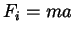, where is the iniertial force, is the object's mass, and is the acceleration.
elastic forces
Deforming the fork requires application of force. In the case of our tuning fork, the force results from its inertia. Let's make the simplifying assumption that the fork acts like an ideal spring. That means that as the fork is bent from the vertical ( in the figure), the elastic force increases proportionately to . So, 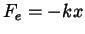, where is the elastic force, is the spring constant (how stiff the fork is), and the minus sign indicates that the direction of the force is opposite the directio of the bend (always towards ).
So, we pull the fork and release it. The elastic force results in an acceleration towards and the tip speed builds up. When the tip passes , the elastic force decelerates the tip, it stops, and the whole thing repeats. If we ignore troublesome issues like air resistance that would slow down the vibration, the 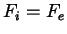. Solving for we obtain:
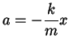 | (1-1)

Acceleration is the change in velocity over time, or its derivative, 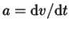; velocity in turn is the derivative of distance, 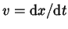. So, acceleration is the second derivative of :
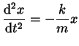 | (1-2)

As an aside, this kind of equation -- which relates a derivative of something to itself -- is called a differential equation. I'll bet you didn't know they were that simple! To solve a differential equation, we look for a function of that, when plugged in for , will satisfy the equation. This is analogous to solving an algebraic equation, where we look for a number that satisfies. The only difference is that numbers fall along a one-dimensional number line (unless we're talking about complex numbers), while there is no such neat ordering of functions. So, we need to find a function of whose second derivative is proportional to itself. Can you think of one or two? (Popup answer: and both work)
Luckily, people have been working with functions and differential equations for a while, and so finding such functions is not difficult. For example, consider sinusoids. The first and second derivatives of are:
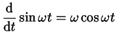 | (1-3)
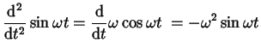 | (1-4)

Therefore, differential equation (1-2) describes simple harmonic motion: sinusoidal vibration of the tuning fork's tip.

Self-Test Exercises
- Solve for in terms of and . (Popup answer: 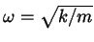.)
- Fork stiffness () clearly affects vibration frequency. As the fork get stiffer ( increases), does the vibration frequency go up or down? (Popup answer: as increases, (which is vibration frequency) increases.)

Sinusoid Phase
The same argument can be used for . In fact, cosine is just a delayed version of sine, as 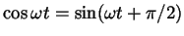. So, a more general solution to (1-2) would be:
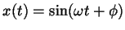 | (1-5)

In (1-5), is called the sinusoid's phase: the time closest to when 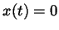(for the case of a sine; it would be where 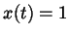for a cosine). Depending on when we hit the tuning fork (and our time reference; the time that we call ), we will get sinusoids of differing phase. What would happen if we hit two identical tuning forks but at different times?
They would vibrate at the same frequency, but would have differing phases and amplitudes (loudnesses). If the two forks were close together, we would heard the sum of their tones. What would that sum be? (Popup answer: 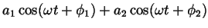, where and are the vibrational amplitudes and and are the two phases.) Simplifying this sum would be involved; we would have to remember all sorts of trigonometric identities and then crank out the algebra. Luckily, we can come up with another representation of a sinusoid which simplifies this problem considerably. In fact, much of the new math we will cover in this course is primarily focused on making the paper-and-pencil work easier.

Phasors
Instead of thinking of a sinusoid as a function which oscillates up and down, let's think of it as something that goes round and round: a rotating vector of length (where is the sinusoid's amplitude). At any point in time, the vector makes an angle 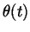with the positive axis. The phase 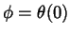is the angle at . As figures 3.2 and 3.3 in chapter 1 show, the sine and cosine functions are the and components of this vector.
If we have two vectors and , we can add them by adding their components. This is done graphically in chapter 1, figure 3.4. The ``tail'' of one vector is placed on the ``head'' of the other, and the sum 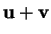is the vector from the origin to the ``head'' of the second vector (the figure in the text shows the sum as a point, without drawing the resultant vector from the origin). Of course, that's just the sum at one point in time. What does look like if and are rotating? (Popup answer: If the s of and are equal, then rotates with them, the magnitudes staying constant. Therefore, is a sinusoid of the same frequency, .)

Complex Exponential Representation
While we used the and axes above as frames of reference (for considering components of the vectors), we didn't actually define what the plane was. Let's imagine that our rotating vectors are in the complex plane, where is the real axis and is the imaginary axis. At any point in time, the location of a vector is therefore a complex number:
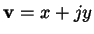 | (1-6)

I use here for 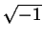, rather than as you've probably seen before, to adhere to the convention used by electrical engineers (who use for current). This will allow us to reduce sinusoidal operations to algebra with complex numbers.
Note that this is the rectangular representation of complex numbers; we can also represent them in polar form (magnitude and angle), written as .

Review Exercises: Complex Numbers
- What is the sum of the two complex numbers 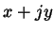and 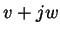? (Answer: You add the reals and imaginaries separately, yielding 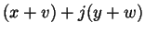.)
- What is the product of the two complex numbers and ? (Answer: It works just like multiplying polynomials, (remember that 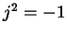).)
- Convert the complex number 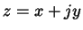to polar form, . (Answer: 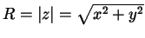; 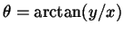.)
- Multiply the two polar-form complex numbers 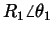and 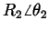. (Answer: 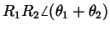)
So, we have an easier-to-manipulate representation of a sinusoid at one point in time. But, we want to represent a rotating vector. Let's talk about a ``standard'' sinusoid -- one with unit amplitude -- and let's call this 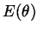. We know from our first discussion of the vector representation of sinusoids that sine and cosine are the and axis projections of the vector, so let's rewrite our rectangular form as:
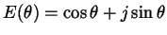 | (1-7)

Can we rewrite the polar form in a similar way? We need a function of that satisfies the same requirements as the rectangular form of equation (1-7). The derivative of (1-7) is:
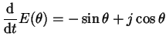 | (1-8)

We note that (1-8) is also just 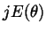What function satisfies the condition that its derivative is proportional to itself? This should bring back fond memories of our tuning fork:

 |  |  | (1-9)
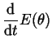 |  | 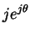 | (1-10)

This is the complex sinusoid representation. It has the property that 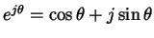; also called Euler's formula (``Euler'' is pronounced ``oiler''). It will make our work much simpler. For example, raising the complex sinusoid to a power is equivalent to rotating the vector:
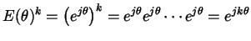 | (1-11)

As you can see in (1-11), raising to the power is equivalent to multiplying the angle by in the complex sinusoid.
The complex sinusoid in (1-10) is one with unit amplitude. The representation for a general vector must therefore be .

Self-Test Exercises
- Multiply the two complex sinusoids and . (Answer: Just like multiplying the polar representation of two vectors, 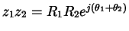.)
- The complex conjugate is indicated by . If , 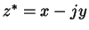. What is the complex conjugate of the complex sinusoid, ? (Answer: Like the polar representation, it has the same magnitude but a negative angle, .)
- Answer the following for :
  - What is 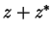? (Answer: 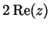)
  - What is 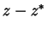? (Answer: 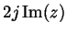)
  - What is ? (Answer: 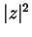)
Going back to (1-11), we can now write an expression for a complex sinusoid as a function of time (a rotating vector). The angle of the sinusoid is a function of time, 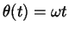, where is its frequency (just as for our original sinusoids):
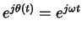 | (1-12)

This rotating complex sinusoid is called a phasor (with apologies to Captain Kirk).

Tuning a Guitar
When a person tunes a guitar, they usually tune just the lowest string to a reference (a pitch pipe, for example). Then, they finger that string to produce the same note that the next higher string should. If the second string does produce the same tone, they can hear that. If the second string is out of tune, it will produce a slightly different tone, and they can hear beating. Beating is what results when two sinusoids at different frequencies are added.
Previously, we added two sinusoids at the same frequency, and saw that the result is another sinusoid at that same frequency. That is the case when the second string is in tune. Let's now add two complex sinusoids with different frequencies, and 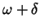, where the difference between the two frequencies is 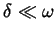:

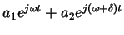 |  | 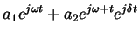 | (1-13)
 |  | 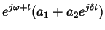

This has the form of a complex sinusoid of frequency and amplitude that is a function of time: 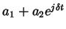. The textbook chapter 1, figure 9.3 presents the graphical version of this, which looks like a top view of the amusement park ``octopus'' ride. There are times when the adds a factor of up to to the first sinusoid and times when it subtracts a factor of up to . The result is the beating waveform seen in chapter 1, figure 9.1. It would be nice for the students to be able to click on a link and hear a beating sound. I will try to generate the sound itself.

Vibrating Strings
We ended the last section talking about tuning guitars, but really the action of guitar strings was not covered there. Let's talk about strings now. A string is different than a simple harmonic oscillator; it introduces a new issue -- that of the spatial dimension along the string. The motion of a string is a function of two variables: (here, the point along the string, with one end considered ) and time, . If the displacement of the string from its rest position is called , then is the function 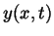.
Whenever we take derivatives of functions of more than one variable, we must consider them to be partial derivatives. The partial derivative of a function with respect to a variable is performed by treating all the other variables as constants. Some examples:

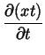
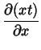
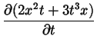 |  | 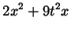
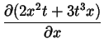 |  | 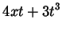

In the discussion of the tuning fork, we described its motion using a differential equation that related its acceleration (second derivative of position) to its position. Our textbook uses the same method to describe the motion of a string. However, in this case, because the derivatives involved are partial derivatives, the resulting differential equation will be a partial differential equation (PDE). The previous differential equation, with no partial derivatives, is termed an ordinary differential equation (ODE). And, nobody likes to be ``ordinary''.
I will dispense with most of the derivation here, concentrating instead on the basic methods and the result. Just as with the tuning fork, we want to write expressions to describe the forces that act on the string. Consider a short segment of string which has been displaced from its rest position. The force that pulls on both ends of the segment is the force that seeks to restore it to its rest position. Its inertia is what seeks to keep it moving. We already know that the inertial force is , or keeping in mind that acceleration is the second derivative of position:
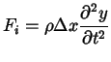 | (1-14)

In this equation, the mass of the string segment is 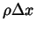, which is its mass per unit length (mass density), , times the segment length. The string isn't flying through the air, so we only care about its motion along one dimension, .
The restorative force is more complex to figure out, but basically we need to remember that the tension on the segment, , is not directed solely in the direction. So, we need to compute the component of tension in the direction, treating tension as a vector. After setting the two forces equal, one can obtain:
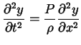 | (1-15)

As the textbook says, is analogous to the tuning fork's spring constant, , and to . The interesting thing is the units of this constant. The textbook rewrites (1-15) as the classic wave equation, which describes many wavelike phenomena:
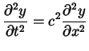 | (1-16)

The constant has been rewritten as so that we can talk about , which is the speed of motion of a wave traveling down the string. 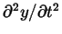is the acceleration of the string in the direction, and 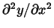is the curvature of the string. As the string becomes more curved, what happens to the restorative force? (Popup answer: it increases.) In guitar terms, what does this correspond to? (Popup answer: picking the string harder.)

Traveling Waves
As I implied in that last paragraph, one solution to the wave equation (1-16) is a traveling wave. Lets assume that we whip the end of the string and produce a ``bump'' traveling down its length. Let's say that 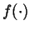is the shape of the bump, and that it is traveling to the right. In that case, the displacement of the string at any point and any time can be related to its displacement at some time in the past: 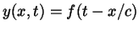. Because the wave is traveling, it reaches point after previous points; the time it takes to reach is directly proportional to the distance it needs to travel and inversely proportional to the speed of motion.
Waves can travel in both directions, and so the general description has rightward and leftward moving waves (which could have different shapes):
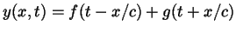 | (1-17)

Fixed Ends
If we're thinking of modeling a stringed instrument, then we really need to keep both ends of our model string from flapping around like a whip. A fixed end doesn't move, so if both ends are fixed, 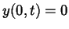and 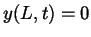(where is the string's length). We still have the general form of the solution of the wave equation given in equation (1-17); it just now needs to satisfy the two boundary conditions. These conditions force 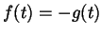(a traveling wave will reflect off a fixed end). Since the wave will reflect off both ends, and neglecting troublesome things like the string's energy being dissipated, reflections at both ends mean that the wave will travel periodically along the string:
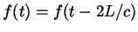 | (1-18)

where 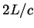is the round-trip time for a wave -- the period of vibration for the string, .
The frequency of vibration for the string is 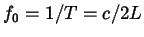, with units of cycles per second, or Hertz (Hz). We can also express frequency in terms of radians per second, 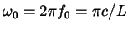. What kind of function is periodic in the manner of equation (1-18)? To make a long story short, one solution is the complex function:
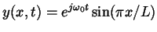 | (1-19)

If you're bothered by the use of a complex function to describe a physical quantity like displacement, then the real part of this can be used, 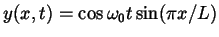.
What does this function look like? (Popup answer: It looks like ``mode 1'' in figure 5.1 of textbook chaper 2.) However, I never said that (1-19) was the only solution to (1-18). It turn out that it is one of a family of solutions:
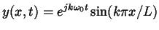 | (1-20)

For each value of , we get a different solution. Each solution's vibrational frequency is an integral multiple, or harmonic, of the fundamental frequency, . In general, we can mix as many of these modes together as we want, and so the general solution of (1-18) is:
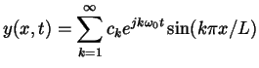 | (1-21)

where the are the magnitudes of each mode.

The Fourier Series
Let's say that we take our string (fixed at both ends) and initially deform it to some arbitrary shape. Before we release it, at , this shape is still described by (1-21), because that describes any vibration:

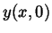 |  | 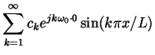 | (1-22)
 |  | 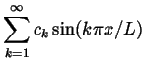

This must be one of the most important equations of all time. It says exactly what you think it says -- any shape (function of one variable) can be expressed as a sum of sinusoids. In this case, the variable stands for distance along the string, but we're free to think of it as time or any other variable. If we do think of the one variable as time, we might as well replace with and with (period of time rather than length). In that form, this is known as the Fourier series. The Fourier series should give you hope that all your work with sinusoids -- real and complex -- is not in vain. For, if we can express any function as a sum of sinusoids, which is trivially easy to do with the complex representation, then perhaps that is all we need to know to process signals.

Assignment 1
- How does fork mass affect tuning fork vibration frequency?
- What musical instruments might be governed by properties analogous to that of a tuning fork?
- When you add two sinusoids with frequencies that differ by , the result is beating. Imagine you're tuning a guitar. As the two strings get closer together in tone, what happens to the beat frequency? Show how this result is predicted by the sum of the complex sinusoids.
- Verify that equation (1-17) is a solution of the wave equation.
- Implement a C++ or Java Complex class for representing complex numbers. You class should include at least the following methods:
  - add()
  - multiply()
  - real()
  - imag()
  - magnitude()
  - angle()
Document your code so that this class could be used by someone else. Write a test program that exercises all of this class' methods. Submit hard copy of your code, your test program output, and your documentation.

About this document ...
Lesson 1: Signals in the Physical World
This document was generated using the LaTeX2HTML translator Version 2K.1beta (1.50)
Copyright © 1993, 1994, 1995, 1996, Nikos Drakos, Computer Based Learning Unit, University of Leeds.
Copyright © 1997, 1998, 1999, Ross Moore, Mathematics Department, Macquarie University, Sydney.
The command line arguments were:
latex2html -split 0 physical-signals
The translation was initiated by Prof. Michael Stiber on 2002-02-01

Up: Dr. Michael Stiber's Home Page
Dr. Michael Stiber stiber@u.washington.edu

